**PM SHRI KENDRIYA VIDYALAYA NO.1 NAVAL BASE KOCHI**

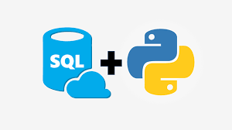

**COMPUTER SCIENCE PROJECT**

**TOPIC: SPACE DATA MANAGEMENT SYSTEM**

**SUBMITED BY: SUBMITED TO:**

**AKARSH MURALI B HEMA CN MADAM**

**XII C PGT(CS)**

**ROLL NO:**

**CERTIFICATE**

This is to certify that **AKARSH MURALI B,** of class XII‘C’ PM SHRI KENDRIYA VIDYALAYA NO.1 NAVAL BASE KOCHI

has done project on **SPACE DATA MANAGEMENT SYSTEM** under the supervision of **HEMA CN**. I have taken interest and have shown at most sincerity in completion of this project. I certify this project to our expectation and as per guidelines issued.

***_________________ _________________***

***INTERNAL EXAMINER EXTERNAL EXAMINER***

***________________***

***PRINCIPAL***

ACKNOWLEDGEMENT

It is my pleasure that I acknowledge my sincere gratitude to our teacher MRs. HEMA CN who taught and undertook the responsibility of teaching the subject computer science. I have greatly benefited from his classes.

I would like to express my sincere appreciation for all the other students of my batch and their fine times that we all shared together.

Finally, I would like to thank our principal SASI E.K who has always been a source of inspiration.

HARDWARE AND SOFTWARE

REQUIRED

● HARDWARE

PC/LAPTOP

● SOFTWARE

PYTHON (latest version)

MYSql Python Connector

CODING

#Connector for connecting MYSql with Python | Time function for timing our prints and outputs

import mysql.connector

import time

#connecting to the database

dbconn = mysql.connector.connect(

host="localhost",

user="root",

password="",

database="space",

auth_plugin = "mysql_native_password"

)

#Function to add a Plant

def add_planet(dbconn, planet_data):

cursor = dbconn.cursor()

sql = "INSERT INTO spacetable (Planets, Parent_Star, Planetary_system, Galaxy, Habitability, Temperature, Type_surface, Nof_moon, Distance) VALUES (%s, %s, %s, %s, %s, %s, %s, %s, %s)"

cursor.execute(sql, planet_data)

dbconn.commit()

cursor.close()

#Function to Edit a planet Information

def edit_planet(dbconn, planet_name, new_data):

cursor = dbconn.cursor()

sql = "UPDATE spacetable SET Parent_Star = %s, Planetary_system = %s, Galaxy = %s, Habitability = %s, Temperature = %s, Type_surface = %s, Nof_moon = %s, Distance = %s WHERE Planets = %s"

cursor.execute(sql, (*new_data, planet_name))

dbconn.commit()

cursor.close()

#fuction to delete a planet

def delete_planet(dbconn, planet_name):

cursor = dbconn.cursor()

sql = "DELETE FROM spacetable WHERE Planets = %s"

cursor.execute(sql, (planet_name,))

dbconn.commit()

cursor.close()

#Function to delete a planet

def display_planets(dbconn):

cursor = dbconn.cursor()

cursor.execute("SELECT * FROM spacetable")

for row in cursor:

print(row)

cursor.close()

#Menu Driven Program

print("Welcome to Space Base. Here, the currently known planets and dwarf planets are in this database.Enter (y) to our data!")

time.sleep(2)

mer = input("Enter y/n:")

if mer == "y":

display_planets(dbconn)

else:

print("Looks like you are intrigued to get into the program")

time.sleep(2)

print("Let get into our program then!!")

ch = "y"

while ch == 'y':

print("1.ADD\n")

print("2.EDIT\n")

print("3.DELETE\n")

print("4.DISPLAY\n")

karma = int(input("Enter your choice(1,2,3,4):"))

#Code after the USER chooses the choice

try:

if karma == 1:

Planets = input("Enter New Planet Name:")

Parent_Star = input("Enter the Parent Star Name:")

Planetary_system = input("Enter the Planetary System Name:")

Galaxy = input("Enter the Galaxy name Name:")

Habitability = input("Is the Planet Habitable?(yes/no):")

Temperature = int(input("Enter its Temperature(Average):"))

Type_surface = input("Enter The planet Surface type(rocky/ice/etc...):")

Nof_moon = int(input("Enter the number of moons of this planet:"))

Distance = int(input("Enter the distance of this planet from Earth:"))

data = [Planets, Parent_Star, Planetary_system, Galaxy, Habitability, Temperature, Type_surface, Nof_moon,

Distance]

add_planet(dbconn, data)

display_planets(dbconn)

elif karma == 2:

Planets = input("Enter Planet for data Editing:")

print("Enter the new values to be edited")

Parent_Star = input("Enter Parent star name:")

Planetary_system = input("Enter Planetary System name:")

Galaxy = input("Enter Galaxy Name:")

Habitability = input("If it is habitable or not(yes/no):")

Temperature = int(input("Enter Temperature(Average):"))

Type_surface = input("Enter the Planet surface type:" )

Nof_moon = int(input("Enter number of moons:"))

Distance = int(input("Enter distance of planet from Earth:"))

data = [Parent_Star,Planetary_system,Galaxy,Habitability,Temperature,Type_surface,Nof_moon,Distance]

edit_planet(dbconn, Planets, data)

display_planets(dbconn)

elif karma == 3:

planet = input("Enter the Planet to be deleted:")

delete_planet(dbconn, planet)

elif karma == 4:

display_planets(dbconn)

else:

print("Your choice is out of range", karma)

#To denote if the code has been successful

finally:

print("Processing!!")

time.sleep(2)

print("Set Done!!")

#To denote if the USER wants to continue the program

time.sleep(2)

ch = input("Would You like to continue?(y/n):")

#The Code when User wants to exit the program

if ch == "n":

time.sleep(2)

print("See You Soon!!")

DATABASE

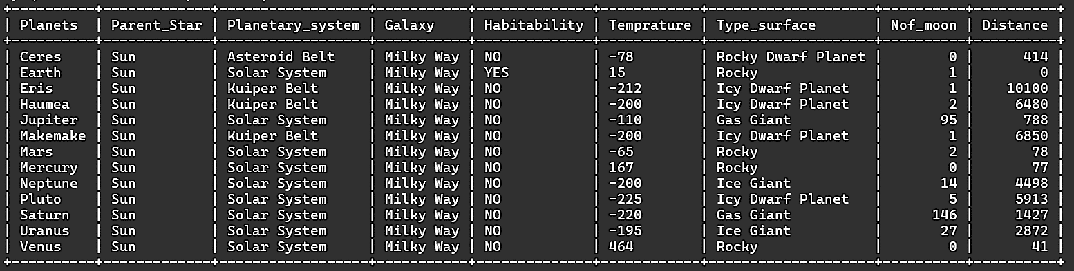

Code for the DATABASE:

CREATE DATABASE SPACE;

USE SPACE;

CREATE TABLE SPACETABLE

(

Planets VARCHAR(50) PRIMARY KEY,

Parent_Star VARCHAR(100),

Planetary_system VARCHAR(50),

Galaxy VARCHAR(50),

Habitability VARCHAR(50),

Temperature VARCHAR(100),

Type_surface VARCHAR(50),

Nof_moon INT,

Distance FLOAT);

INSERT INTO SPACETABLE (Planets, Parent_Star, Planetary_system, Galaxy, Habitability, Temperature, Type_surface, Nof_moon, Distance)

VALUES ("Mercury","Sun","Solar System","Milky Way","NO",167,"Rocky","0","77"),

("Venus","Sun","Solar System","Milky Way","NO",464,"Rocky","0","41"),

("Earth","Sun","Solar System","Milky Way","YES",15,"Rocky","1","0"),

("Mars","Sun","Solar System","Milky Way","NO",-65,"Rocky","2","78"),

("Jupiter","Sun","Solar System","Milky Way","NO",-110,"Gas Giant","95","788"),

("Saturn","Sun","Solar System","Milky Way","NO",-220,"Gas Giant","146","1427"),

("Uranus","Sun","Solar System","Milky Way","NO",-195,"Ice Giant","27","2872"),

("Neptune","Sun","Solar System","Milky Way","NO",-200,"Ice Giant","14","4498"),

("Pluto","Sun","Solar System","Milky Way","NO",-225,"Icy Dwarf Planet","5","5913"),

("Ceres","Sun","Asteroid Belt","Milky Way","NO",-78,"Rocky Dwarf Planet","0","414"),

("Eris","Sun","Kuiper Belt","Milky Way","NO",-212,"Icy Dwarf Planet","1","10100"),

("Haumea","Sun","Kuiper Belt","Milky Way","NO",-200,"Icy Dwarf Planet","2","6480"),

("Makemake","Sun","Kuiper Belt","Milky Way","NO",-200,"Icy Dwarf Planet","1","6850");

OUTPUT

WELCOME Screen:

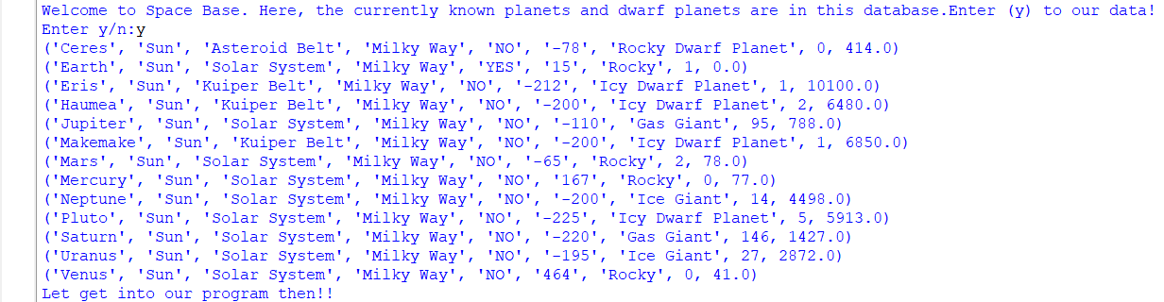

OUTPUT for choice 1:

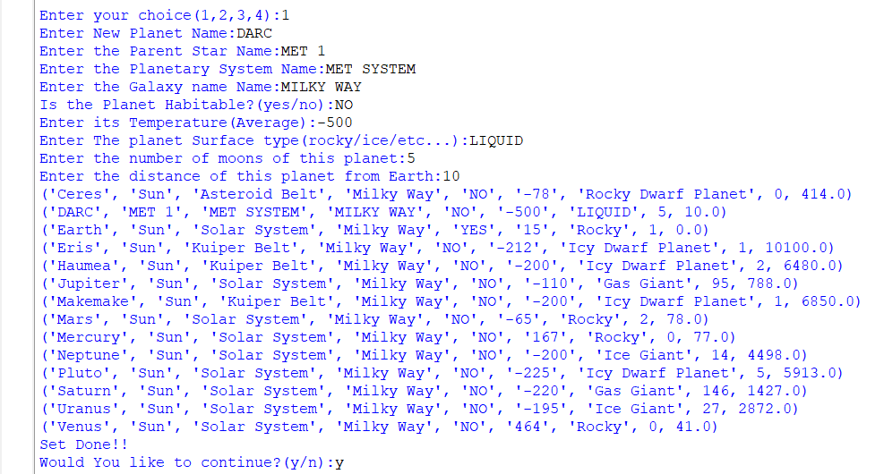

OUTPUT for choice 2:

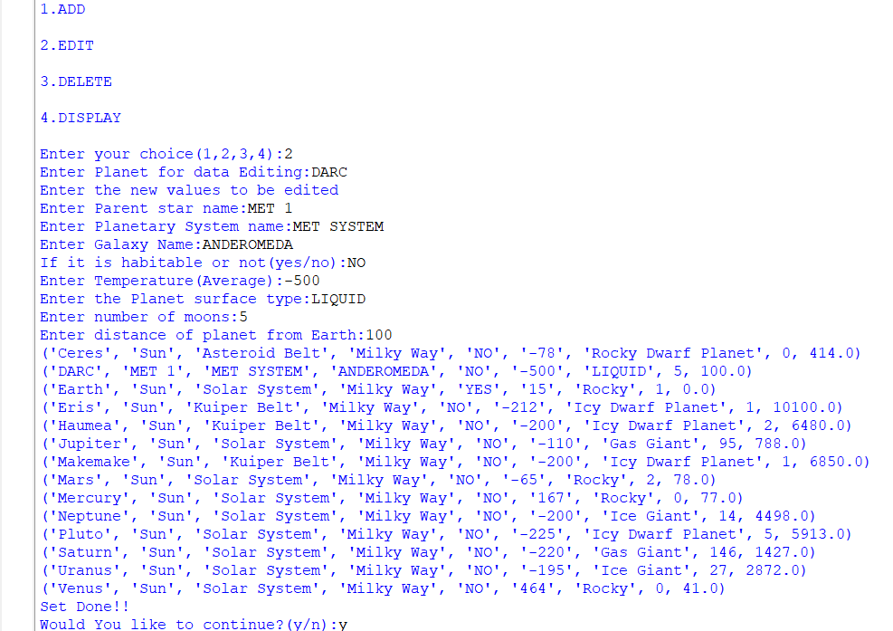

OUTPUT for choice 3:

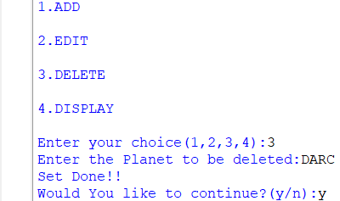

OUTPUT for choice 4:

